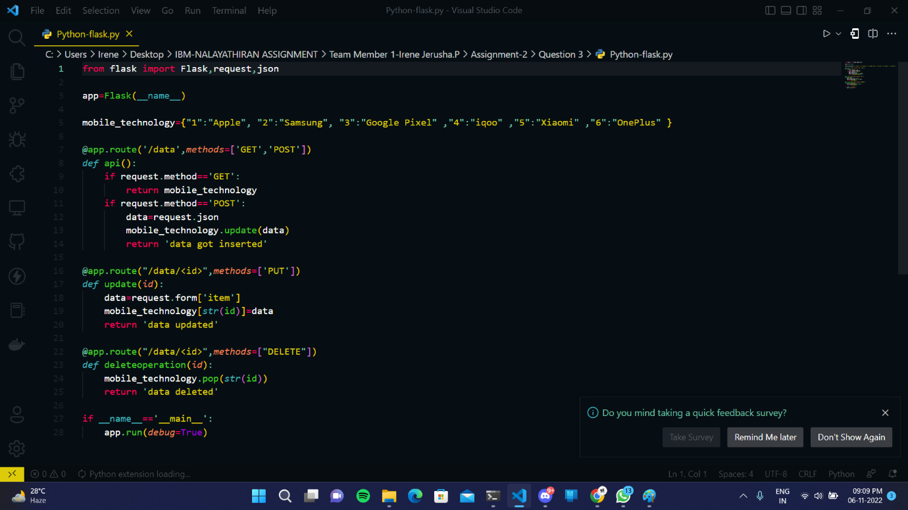**CREATING FLASK PROJECT**